

**SIMATS SCHOOL OF ENGINEERING**

**SAVEETHA INSTITUTE OF MEDICAL AND TECHNICAL SCIENCES**

**CHENNAI-602105**

**INTERNET PROGRAMMING FOR SEREVR SIDE DEVELOPMENT   
(CSA-4301)**

**A CAPSTONE PROJECT REPORT**

*Submitted in the partial fulfillment for the award of the degree of*

**BACHELOR OF ENGINEERING**

**IN**

**COMPUTER SCIENCE AND ENGINEERING**

**Submitted by**

**V.Purushotham(192211742)  
N.Tharun(192211227)**

**Under the Supervision of**

**MR. S. YUVARAJ**

**SEPTEMBER 2024**

**DECLARATION**

We, **V.Purushotham(**192211742), **N.Tharun**(192211227) students of **Bachelor of Engineering in CSE**, Department of Computer Science and Engineering, Saveetha Institute of Medical and Technical Sciences, Saveetha University, Chennai, hereby declare that the work presented in this Capstone Project Work entitled **ONLINE BUS RESERVATION SYSTEM** is the outcome of our own bonafide work and is correct to the best of our knowledge and this work has been undertaken taking care of Engineering Ethics.

V.Purushotham(192211742)

N.Tharun(192211227)

Date:

Place:

**CERTIFICATE**

This is to certify that the project entitled **“ONLINE BUS RESERVATION SYSTEM”** submitted by **V.PURUSHOTHAM, N.THARUN** has been carried out under my supervision. The project has been submitted as per the requirements in the current semester of B. Tech Information Technology.

Teacher-in-charge

MR.S.YUVARAJ

# **Online Bus Ticket Reservation System**

##### **ABSTRACT**

Online Bus Ticket Reservation System is a Web based application that works within a centralized network. This project presents a review on the software program “Online Bus Ticket

Reservation System” as should be used in a bus transportation system, a facility which is used to reserve seats, cancellation of reservation and different types of route enquiries used on securing quick reservations. OBTRS is built for managing and computerizing the traditional database, ticket booking and tracking bus and travel made. It maintains all customer details, bus details, reservation details. In order to achieve the design, Imo Transport Company (ITC) was chosen as a case study because of its strategic importance to Imo State. Structured Systems Analysis and Design Methodology (SSADM) was adopted. In addition, PHP Hypertext Preprocessor (PHP) language was used for the front- end of the software while the back end was designed using MySQL. The software achieved is capable of improving the customer hand and relationship management in ITC operations. It is recommended that despite the present functionality of the designed software, an additional functionality such as the use of E-mail to send tickets and notifications to the customer and an online payment using credit cards/debit cards should be implemented into the system. Furthermore, other operations carried by ITC such as the courier services should also be integrated in order to enhance the system.

**Key words:** OBTRS, Electronic Ticketing, ITC, Reservation, Transportation

**Project Overview**

The Bus Reservation System is a web-based or desktop application that aims to simplify the process of booking bus tickets and managing travel schedules for both passengers and bus operators. It automates key tasks like ticket reservations, seat allocation, payments, and record maintenance, ensuring efficient service delivery.

**Key Features**

1. **User Authentication & Profiles**:
   * **User Registration/Login**: Users can create accounts with personal information (name, email, phone number) and log in to manage bookings.
   * **Admin Login**: Admins manage buses, routes, and bookings. They can add, edit, or delete bus schedules and seat details.
2. **Search & Book Tickets**:
   * **Search for Buses**: Users can search for available buses by selecting the source and destination, travel date, and bus type (AC, non-AC, etc.).
   * **Real-time Seat Availability**: The system provides real-time information about available seats on each bus.
   * **Select Seat**: Passengers can view available seats and choose preferred ones while booking.
3. **Bus Schedule Management**:
   * **Bus Route Setup**: Admins can define routes, including source, destination, stops, and timings.
   * **Bus Details**: Information on bus types (deluxe, sleeper, etc.), amenities (Wi-Fi, charging points), and fare structures.
4. **Booking and Payments**:
   * **Booking Confirmation**: After selecting a seat, users receive a booking confirmation with details like bus number, boarding time, and seat number.
   * **Online Payment Integration**: Secure payment options like credit/debit cards, digital wallets, and net banking can be integrated.
   * **Booking History**: Users can view and manage past bookings, including cancellations or rescheduling.
5. **Ticket Management**:
   * **E-tickets**: Upon successful payment, users receive an e-ticket with a QR code for easy boarding.
   * **Ticket Cancellation & Refunds**: Users can cancel tickets and receive a refund based on predefined policies.
   * **Reviews and Feedback**: Passengers can leave reviews or provide feedback on their travel experience.
   * **Discounts and Offers**: The system can manage promotional codes or discounts for regular customers or seasonal offers.

**Benefits**

* **Convenience**: Passengers can book tickets from anywhere, at any time, reducing manual bookings.
* **Efficiency**: Bus operators can manage schedules and bookings more effectively, minimizing errors.
* **Transparency**: Real-time seat availability, pricing, and schedules provide transparency for users.
* **Scalability**: The system can handle a large number of users and bookings as the business grows.

This project would benefit bus operators, travel agencies, and passengers by streamlining the reservation process and improving overall customer service.

### ****Problem Description: Building a Simple Bus Reservation Software****

Design and develop a simple bus reservation software that allows users to reserve seats on a bus for a specific route. The system should allow users to view available buses, select a route, choose a seat, and confirm their reservation. It should also provide basic management features for adding buses, routes, and monitoring reservations for administrators.

#### **Requirements:**

The primary goal of this project is to create a basic bus reservation system with the following features:

### ****Functional Requirements****:

1. **User Interface**:
   * **User Registration/Login**: Allow users to register with basic information (name, email, phone number) and login to their accounts.
   * **Bus Search**: Users should be able to search for buses by specifying the source, destination, and travel date.
   * **Seat Selection**: After choosing a bus, users should be able to view available seats and select a seat for reservation.
   * **Booking Confirmation**: Once a seat is selected, the user should be able to confirm the booking, and a confirmation message or receipt is generated.
   * **Cancel Reservation**: Users should have the ability to cancel their reservation if needed.
2. **Bus and Route Management** (for Admin):
   * **Bus Management**: Admins should be able to add new buses, edit bus details (bus number, type, capacity), and delete buses if necessary.
   * **Route Management**: Admins can create routes by specifying the source, destination, and timings for each bus.

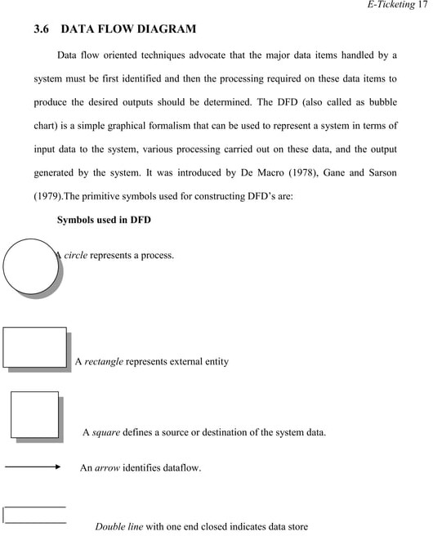

### ****Expected Outcome****:

The resulting bus reservation software should provide a simple, functional platform where users can book bus tickets, and admins can manage the bus and route details. The software will automate the booking process, reducing manual errors and making it easier for both passengers and operators to manage bus reservations.

This problem will help build foundational software development skills, including database management, user interface design, and basic CRUD operations.

This simple implementation covers the basic functionality of bus reservation: adding buses, booking, and canceling seats. You can expand it further by adding features like user authentication, payment gateways, and a graphical user interface (GUI).

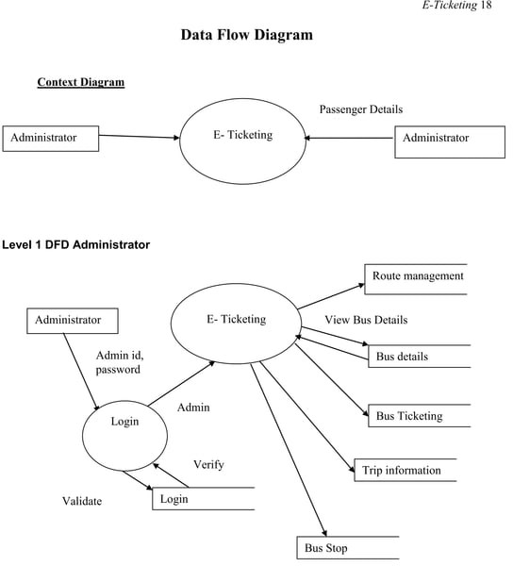

### ****Description****

This section outlines the **User Interface (UI)** design and **features** for the **Bus Reservation System** based on the previous Python command-line implementation. In this case, I will describe a web-based or desktop-based graphical interface with basic usability and features. The UI will be easy to use, allowing users to search for buses, book seats, and manage bo

**2. Features**

1. **Search for Buses**:
   * **UI Design**: Simple input fields where users can specify:
     + **Source**: Dropdown or text field with autocomplete for cities.
     + **Destination**: Same as source.
     + **Travel Date**: Calendar widget to pick the date.
     + **Search Button**: Initiates the search.
   * **Feature**: After submitting, the system shows available buses with options like bus number, timings, seat availability, and price.
2. **Bus Listing and Selection**:
   * **UI Design**:
     + **List of Buses**: Each result displays bus details (bus number, type, travel time) and a button to “View Seats”.
     + **View Seats Button**: Redirects users to the seat selection page.
   * **Feature**: Shows all available buses between the selected source and destination.
3. **Seat Selection**:
   * **UI Design**:
     + **Bus Layout**: Visual grid displaying seats (e.g., 5 columns and 8 rows).
     + **Available Seats**: Green color.
     + **Booked Seats**: Grey color (non-clickable).
     + **Selected Seats**: Yellow color (clickable).
     + **Proceed to Payment Button**: At the bottom of the page after seat selection.
   * **Feature**: Users can click on available seats to select, then proceed to the payment screen.
4. **Booking Confirmation & Payment**:
   * **UI Design**:
     + **Payment Page**: Form fields for entering payment details (e.g., credit card, wallet).
     + **Booking Summary**: Displays selected seats, total cost, and user details.
     + **Pay & Confirm Button**: Finalize the reservation after entering payment details.
   * **Feature**: Securely processes payments and confirms booking. The user is redirected to the “Booking Confirmation” page with ticket details (bus number, seat number, boarding time).
5. **Booking History (My Bookings)**:
   * **UI Design**:
     + **List of Bookings**: Displays all past and upcoming bookings.
     + **View Ticket Button**: Opens booking details like seat number, travel date, and bus number.
     + **Cancel Button**: For upcoming bookings, users can click to cancel the reservation.
   * **Feature**: Allows users to view all of their bookings, and manage cancellations.
6. **User Registration & Login**:
   * **UI Design**:
     + **Registration Page**: Simple form to collect name, email, phone number, and password.
     + **Login Page**: Email and password input fields.
   * **Feature**: Users register or login to book and manage tickets.

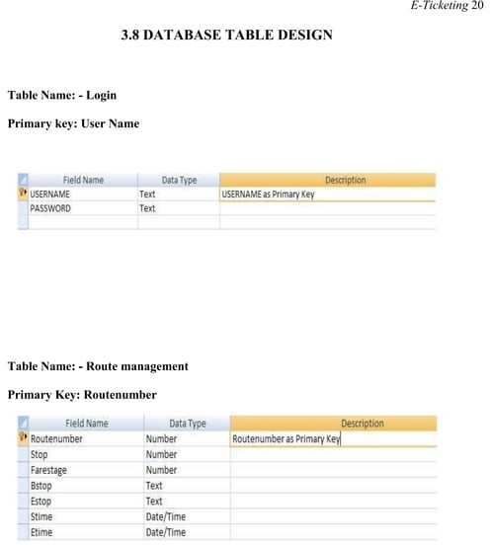

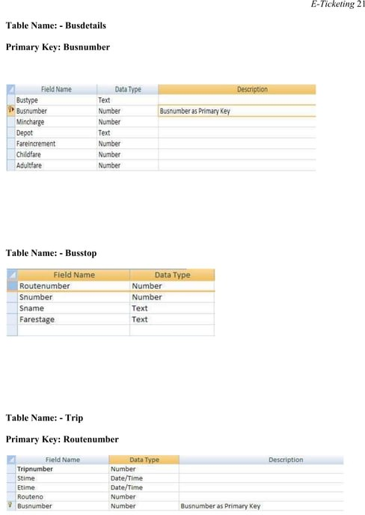

1. **Admin Dashboard**:
   * **UI Design**:
     + **Left Sidebar Menu**: Links to “Add Bus”, “Manage Buses”, “View Bookings”, and “Manage Routes”.
     + **Main Panel**: Display summary statistics (total buses, total bookings, total passengers).
   * **Feature**: Admins can monitor system activity and manage all operations from a central dashboard.
2. **Bus and Route Management**:
   * **UI Design**:
     + **Add Bus Page**: Form to enter bus number, total seats, and type (e.g., AC, Sleeper).
     + **Manage Buses Page**: List of all buses with “Edit” and “Delete” buttons.
     + **Add Route Page**: Form to create routes by selecting source, destination, and timings.
   * **Feature**: Admins can add and manage bus routes and details, ensuring availability for passengers.
3. **View and Manage Bookings**:
   * **UI Design**:
     + **Booking Table**: List of all bookings with fields like user name, bus number, seat number, and booking status.

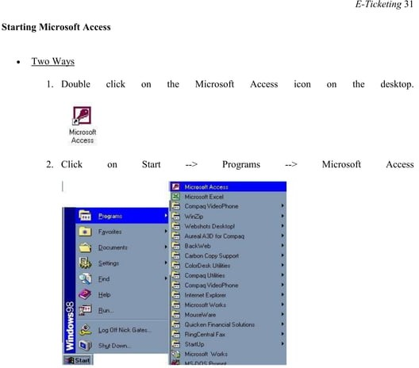

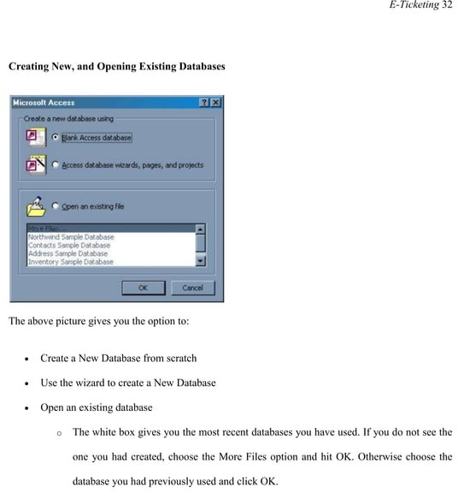

### ****Operations on Bus Reservation System****

In a bus reservation system, the primary operations involve booking tickets, managing bus schedules, routes, and users' bookings. Below is a detailed description of the key operations that occur for **users (passengers)** and **administrators (bus operators/admins)**. These operations are split into user-facing and admin-facing functionalities.

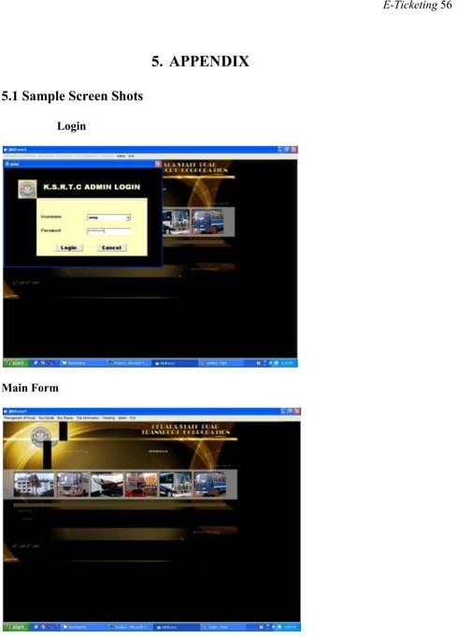

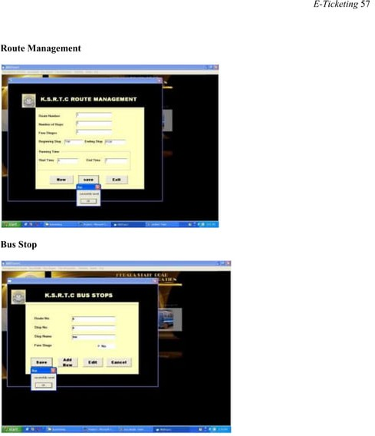

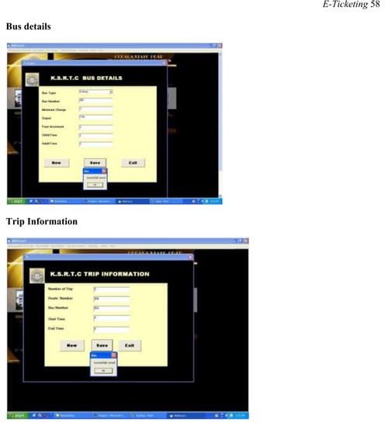

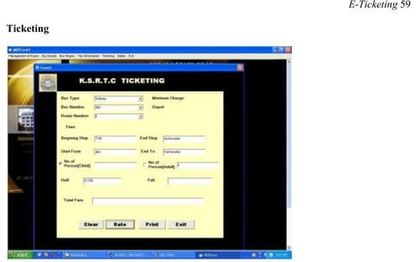

Top of Form

Bottom of Form

### Research Methodology

The system of collecting data for research project is known as research methodology. The data may be collected for either theoretical or practical research for example management research may be strategically conceptualized along with operational planning method and change management. Information which was used for this study was carried out by oral interview.

For any project to be completed, it has to go through stages called Development Life Cycles. System Development Life Cycle (SDLC) is the process of understanding how an Information System (IS) can support business needs, designing the system, building it and delivering it to users. The SDLC composes of four phases: Planning, Analysis, Design and Implementation.

**Conclusion :**

It can be observed that computer applications are very important in every field of human endeavor. Here all the information about customer that made reservation can be gotten just by clicking a button with this new system, some of the difficulties encountered with the manual system are overcome. It will also reduce the workload of the staff, reduce the time used for making reservation at the bus terminal and also increase efficiency. The application also has the ability to update records in various files automatically thereby relieving the company’s staff the stress of working from file security of data.

This project, as a whole, will give a new way in bus reservations and ticketing processes. The automation and management of seats and reservations will be done online. However, this project does not limit the walk-in passengers that is passengers who visit the company’s counter because it also caters for them.